## Current deployment setup.

Current deployment setup is a kubernetes cluster with namespace for each user/username.

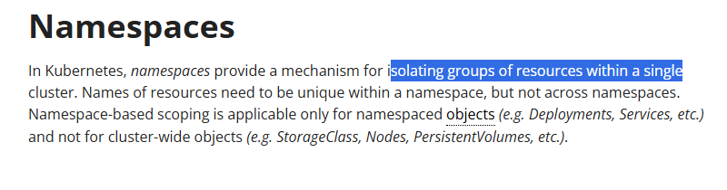

## To be done

* Replicate hc-01 concept, described below in the main HackCubes application.

—

Created a testing environment **hc-01** to simulate **start | stop** operation via buttons.

**Features of hc-01**

1. Checks for deployments folder under root folder.
2. Attempts to apply all the files inside the deployment folder when the start button is clicked by the end user and in a prompt asks for namespaces’s name and thus creates an instance with that name entered

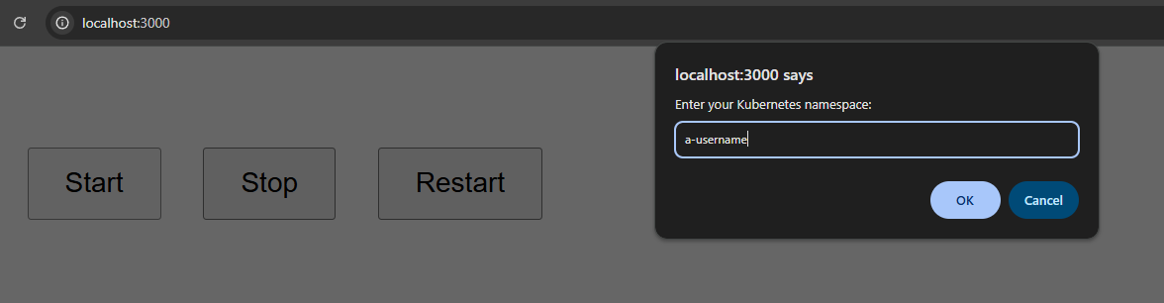

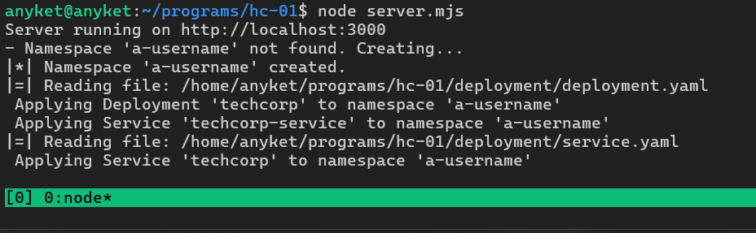

It reads and applies the deployment files!

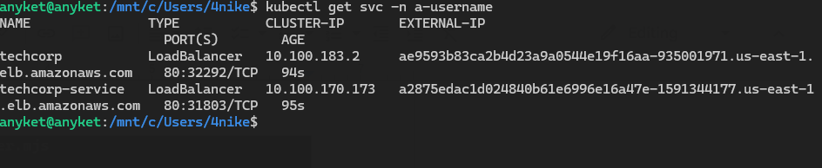

Challenge running.

1. Deletes the namespace when the delete button is clicked.

**Instructions :**

<https://www.npmjs.com/package/@kubernetes/client-node>

Use the following npm package for more features, such as host name retrieval for a specific user/namespace.

<https://github.com/HackCubes/WebChallenges>

Use deployment files under /deployment folder of each challenge file and make sure to remove the **namespace : user1** line from each deployment file.